

“Cyber Security Tips for Students”

Student name : Saher Zulfiqar Saddal
Roll no : 013
Department : ADP-IT
Section : Blue
Subject : ICT LAB
Submitted To : Mam Haniya
Submission Date : 5TH December, 2025

zz

CYBER SECURITY

COMPUTER SCIENCE, TECNOLOGY AND APPLICATIONS
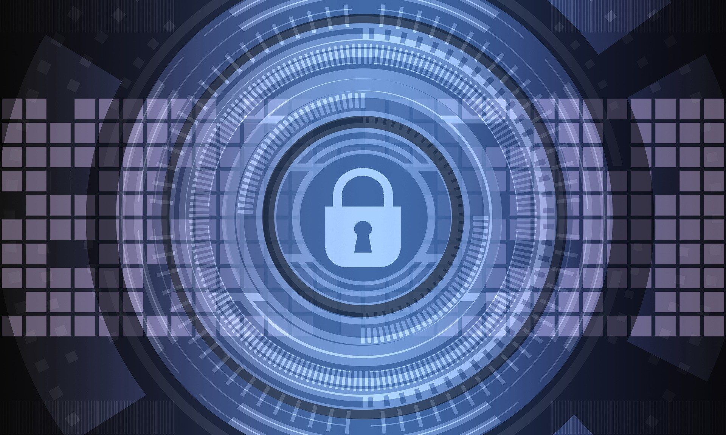

z
12TH Edition

IMPROVEMENTS NEEDED, NATIONAL STRATEGY, AND OPERATIONAL TECNOLOGY
SANDER T. KARLSENKARLSEN
Edited by

2025
SNOVA

Table of Contents
Introduction 2
What Is Cyber Security? 3
Why Do Students Need It? 3
Common Online Dangers 3
PASSWORD SAFETY 4
Creating a Strong Password 4
Password Tips 4
Safe Browsing Practices 5
How to Browse Safely 5
What Is HTTPS? 5
Examples of Safe & Unsafe Websites 6
WEBSITE SAFETY 6
Check if a Website Is Safe 6
Avoid Using Public Wi-Fi for Sensitive Work 6
Use a VPN 6
Basic Cyber Safety Tools 7
Install Antivirus Software 7
Keep Your Device Updated 7
Enable Two-Factor Authentication (2FA) 8
Hyperlinks 8
Benefits of Antivirus Software 8
ONLINE SCAMS & HOW TO AVOID THEM 9
Types of Online Scams 9
How to Identify a Scam 9
What To Do If You Get Scammed 9
Suspicious Emails 9
How to Spot Suspicious Emails 9
Safe Practices 9
Equation 10
CYBER ETHICS & AI PROTECTION 10
Cyber Ethics 10

Good Online Behavior 10
AI in Cyber Security 10
How AI Helps 11
Cyber Security Careers for Students 11
Conclusion 11

C
yber security is becoming one of the most important skills for students today. We use the internet for studies, social media, banking, and even daily communication. Because of this, our personal information is always at risk.

Introduction
Cyber security means protecting your data, devices, and online accounts from people who try to steal or misuse them. With just a few simple habits , students can stay safe while enjoying the benefits of the digital world.
Figure 1. Cyber Security Illustration

Simple Steps to Stay Safe
Here are a few habits that every student should follow:
- Use strong and unique passwords
- Think before clicking any link
Avoid sharing personal information publicly
These small actions can protect you from big problems.

What Is Cyber Security?
Cyber security refers to the tools and techniques used to protect computers, mobile phones, networks, and online accounts from unauthorized access or harmful attacks.
It ensures that your personal information, passwords, and digital data stay safe from hackers.

Why Do Students Need It?
Students spend a lot of time online using:
- Social media
- Online classes
- Email
- Banking apps
- Cloud storage
Because of this heavy online use, students are easy targets for cybercriminals.

Common Online Dangers

“Your online safety is your responsibility — protect it before it’s too late.”

PASSWORD SAFETY

Creating a Strong Password
A strong password protects your accounts from hackers. A good password should be long, difficult to guess, and different from your personal information.
Here are the important things every strong password must include:
- Uppercase letters (A–Z)
- Lowercase letters (a–z)
- Numbers (0–9)
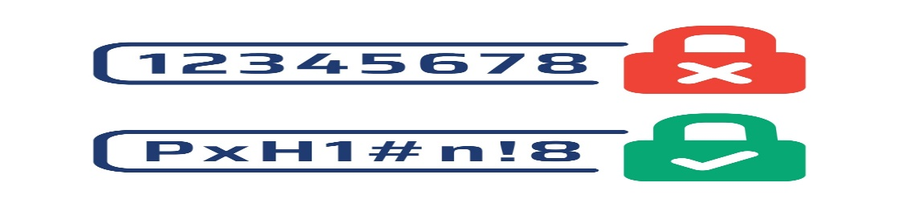
- Special characters (! @ # $ % & *)

Figure 2. Example of a strong password

Password Tips
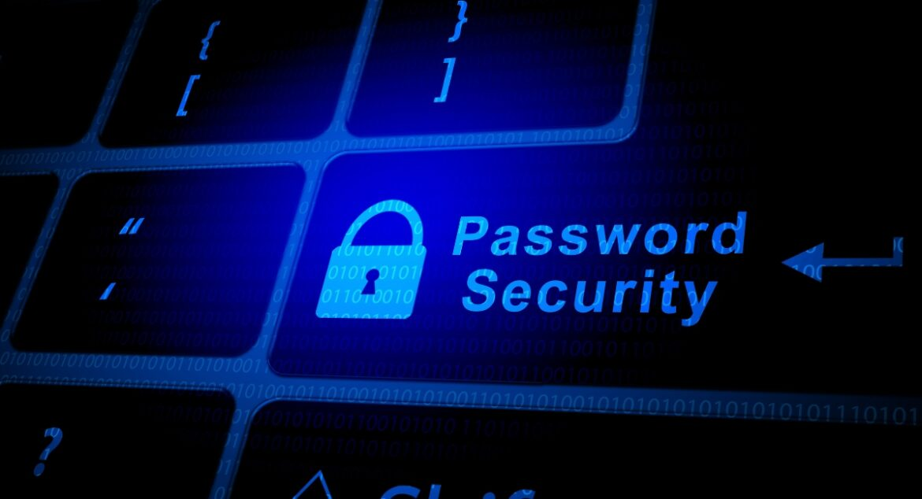
• Do not use your name or date of birth.
• Avoid repeating the same password everywhere.

Figure 3. Password Security practices

Password Strength Comparison
Password Example | Strength
student123 | Weak
S@her2025! | Strong

Safe Browsing Practices
Safe browsing means using the internet carefully so you do not fall into scams, viruses, or fake websites. Students must always check links, website addresses, and security signs before entering personal information online.

How to Browse Safely
- Always check the website address (URL).
- Do not click unknown or suspicious links.
- Avoid downloading files from untrusted websites.

What Is HTTPS?
When a website starts with HTTPS, it means the connection is secure and your data is protected. You should only enter passwords, emails, or payment details on HTTPS websites.
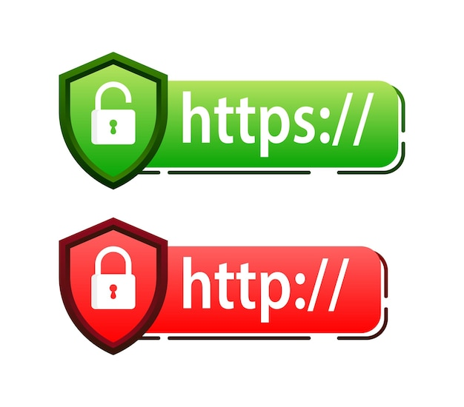
S = Secure
Shows a lock symbol in the address bar
Protects your information from hackers
Figure 4.HTTPS lock showing a secure website connection

Examples of Safe & Unsafe Websites
- https://www.google.com — Safe
- https://www.lms.yourcollege.edu — Safe
- http://freemovies-downloads.net — Unsafe
- http://claim-free-prize.today — Fake & dangerous

WEBSITE SAFETY

Check if a Website Is Safe
Before entering any information, always check these signs:
- HTTPS in the URL
- A lock icon next to the link
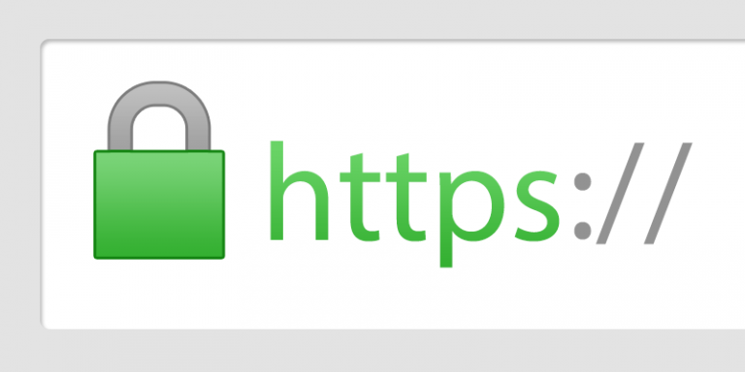
- Correct spelling of the website
Figure 5 Secure HTTPS Lock Symbol

Avoid Using Public Wi-Fi for Sensitive Work
Do NOT open the following on public Wi-Fi:
- Banking apps
- University portals
- Email

Use a VPN
A VPN hides your identity and protects your online activity when browsing.

Basic Cyber Safety Tools

Install Antivirus Software
- Antivirus protects your device from viruses, malware, and harmful files.
- It also warns you when a website or download is unsafe.

Figure 6. Antivirus protecting the device

Keep Your Device Updated
- Updates fix security problems and make your system stronger.
- If you ignore updates, hackers can easily attack your device.
Figure 7. Device updating for better safety

Enable Two-Factor Authentication (2FA)
- Two-Factor Authentication adds an extra security code during login.
- Even if someone knows your password, they cannot open your account without the code

Hyperlinks
Hyperlink #1
Cybercrime Annual Report
Hyperlink #2
National Cyber Crime Website
Hyperlink #3
Online Safety Guidelines

Benefits of Antivirus Software
● Blocks harmful files
● Scans your device

ONLINE SCAMS & HOW TO AVOID THEM

COLUMN 2

Types of Online Scams
• Scholarship scams
• Fake job offers
• Lottery or prize messages
• Fake tech support
• Phishing emails
How to Identify a Scam (Part 1)
• Too-good-to-be-true offers
• Spelling or grammar mistakes

COLUMN 2

How to Identify a Scam
• No verified contact information
• Threatening messages like “Your account will be blocked”

What To Do If You Get Scammed
• Do not reply to scam messages
• Report to cybercrime authorities
• Take screenshots as proof

Suspicious Emails

How to Spot Suspicious Emails
• Emails from unknown or strange senders
• Subject lines that create fear or urgency
• Messages claiming “You won a prize!”
• Attachments ending in .exe, .zip, .rar
• Emails asking for passwords or bank details
• Links that look suspicious or unusual

Safe Practices
• Use your school email for academic communication
• Never click unknown links or attachments
• Check the sender’s email address carefully
• Delete spam messages immediately
• Block and report suspicious senders
• Always keep your email account secured with 2FA

Equation

$$Risk=Thread×Vulnerability$$

CYBER ETHICS & AI PROTECTION

Cyber Ethics
Cyber ethics means using the internet in a responsible and respectful way.
Students should always follow good behavior while using digital platforms.

Good Online Behavior
- Do not hack other people’s accounts
- Do not spread fake news
- Do not cyberbully anyone
- Respect everyone’s privacy
- Think carefully before posting anything online

AI in Cyber Security
Artificial Intelligence (AI) is making cyber security stronger and smarter.
AI can detect danger faster than humans and helps protect systems automatically.

How AI Helps
- Detects suspicious activity
- Blocks harmful websites
- Identifies malware
- Protects networks 24/7 without any break

Cyber Security Careers for Students
Cyber security offers many career opportunities for students who want to work in this field:
- Ethical Hacker
- Cyber Security Analyst
- Network Security Engineer
- Digital Forensics Expert
- Bottom of Form

Conclusion
In today’s digital world, online safety is not just a technical skill — it is something every student and internet user must understand. By learning about different types of scams, strong passwords, secure browsing, and reporting methods, we become more confident and responsible while using technology. Cyber threats are always changing, but basic awareness and careful behaviour can protect us from most risks.
Overall, online safety is a shared responsibility. When we think before we click, avoid sharing personal information, verify sources, and report suspicious activity, we help create a safer online environment for ourselves and others. With the right habits and awareness, we can enjoy the internet without falling into common traps or scams.

References
- National Cyber Security Centre. (2023). Password safety guidelines. https://www.ncsc.gov.uk
- FIA Cyber Crime Wing. (2024). Report online scams & cyber issues. https://www.fia.gov.pk
- Google Safety Center. (2024). Safe browsing practices. https://safety.google
- Norton. (2024). Benefits of antivirus software. https://www.norton.com
- Microsoft Security. (2024). How to identify phishing emails. https://www.microsoft.com/security

